Adoption Einkauf

Einakuaf (Purchase) is purchase module to buy something from supplier when we need some part or goods to fulfill the stock.

Type of Document:
Anfrage (EAA): Request Quote
Bestellung (EB): Purchase Order
Wareneneingang (EWE): Stock Receive
Rechnungkontroll (ERR): AIP Invoice voucher

- Anfrage (EAA) --> Bestellung (EB)
- Change the BelegNumber to the last number and create it.
- 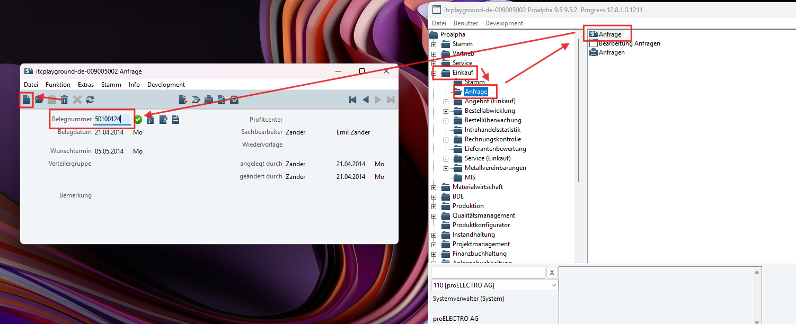
- Create new position. (What Teile should fill you can see on other document number)
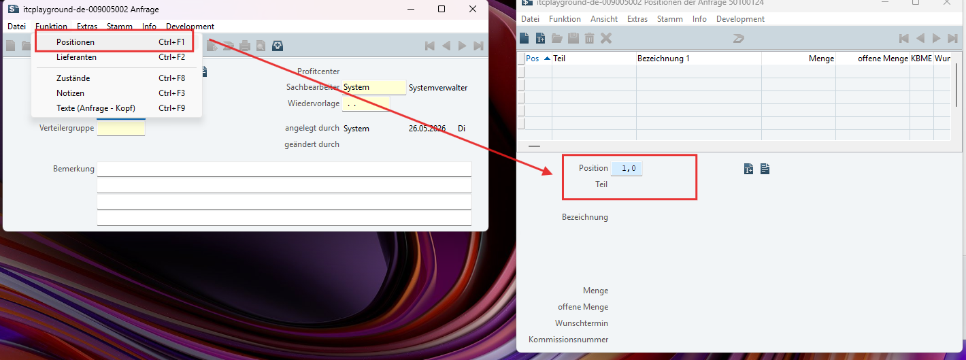
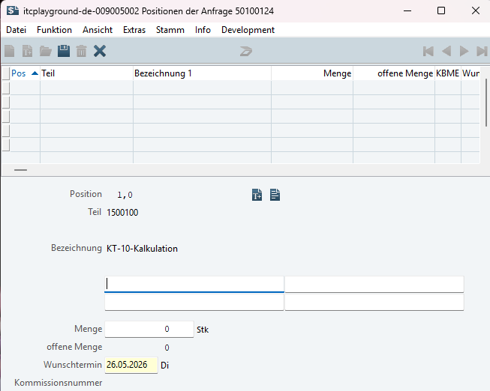
- Create new Lieferant (to buy the goods) from who?
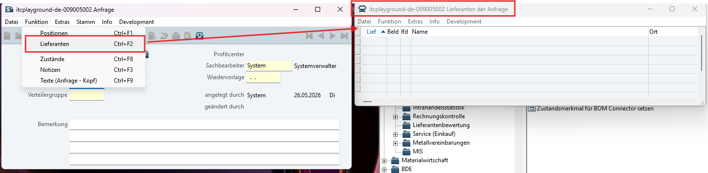
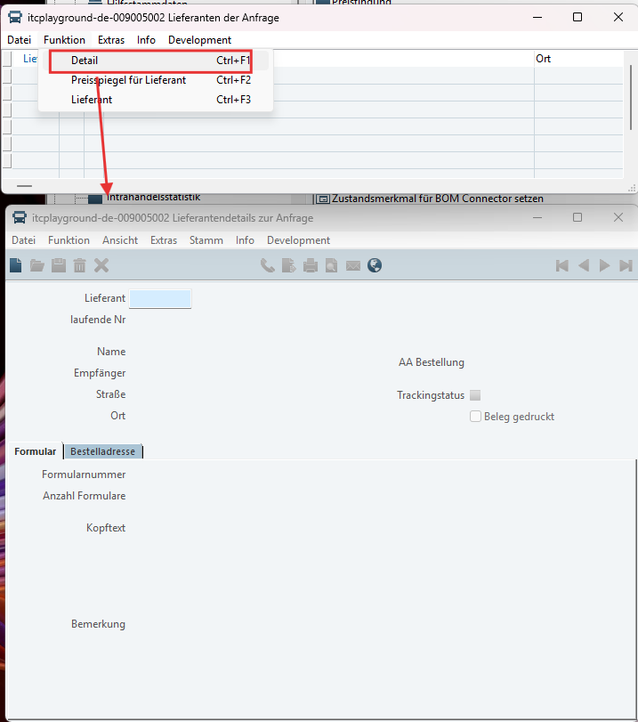
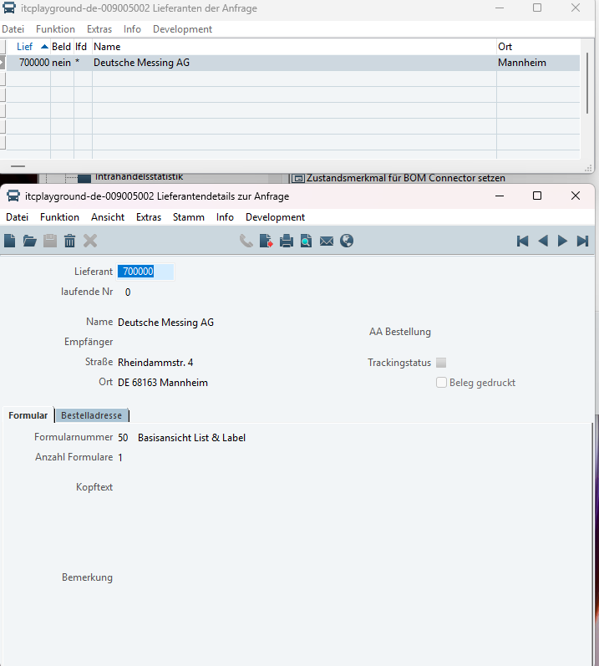
- After creating Lieferant, go back to position to define the price value of position
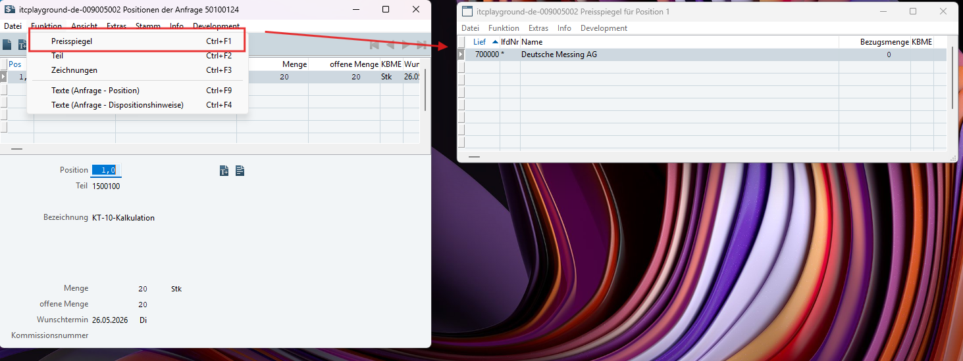
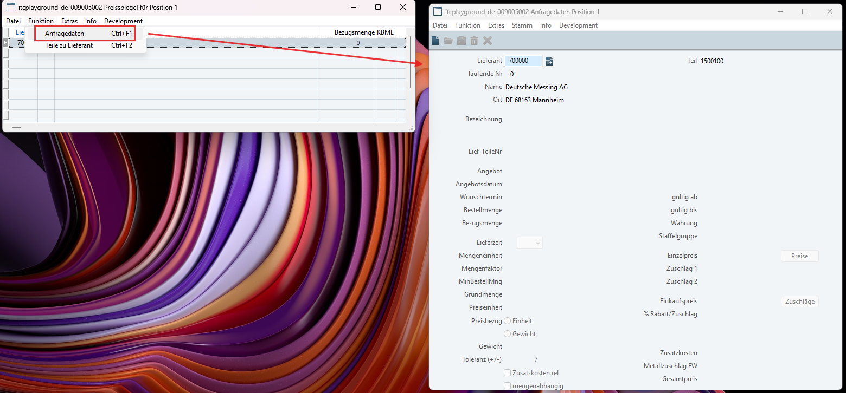
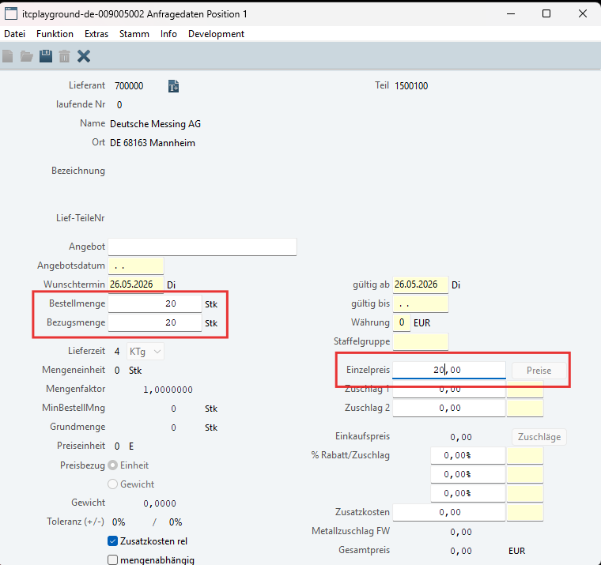
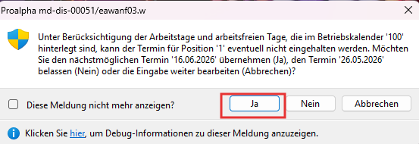
- Create Lieferant-teile
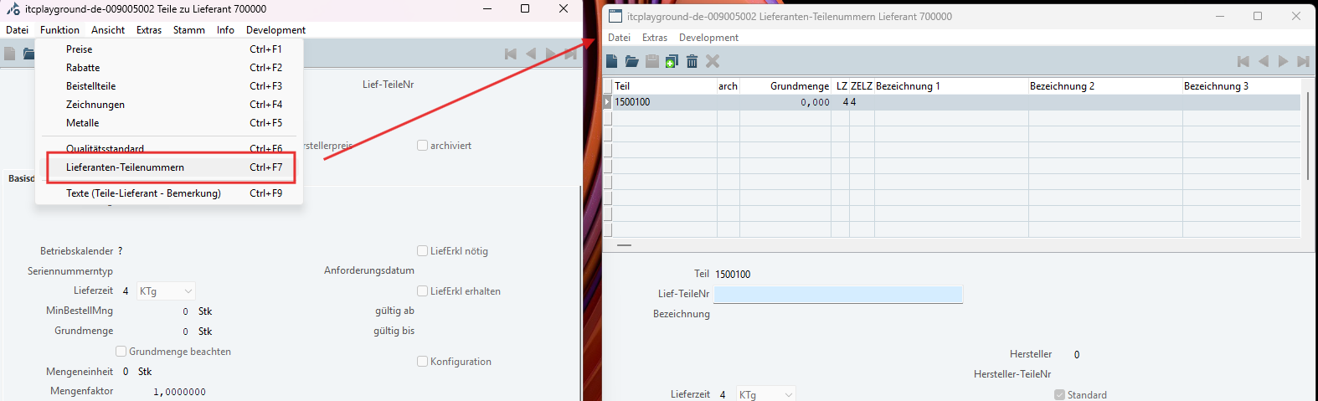
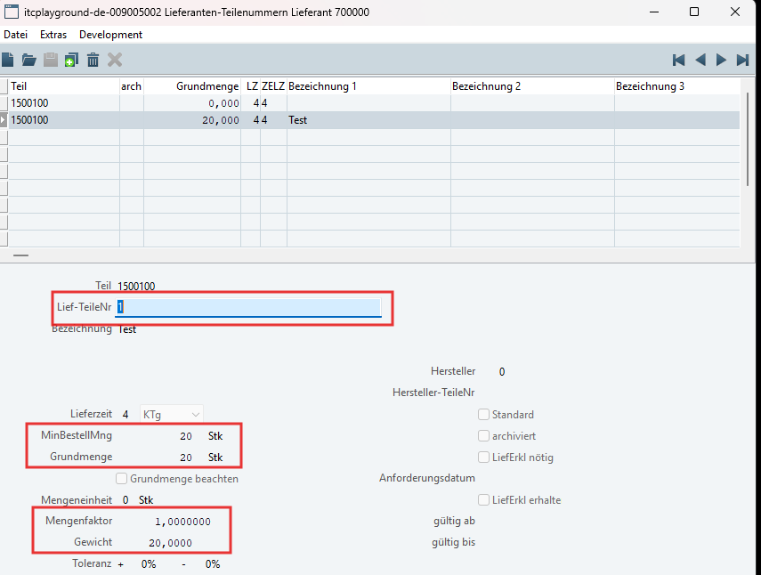
- Then after we create relation between teile and lieferant then create the price range to buy from this supplier
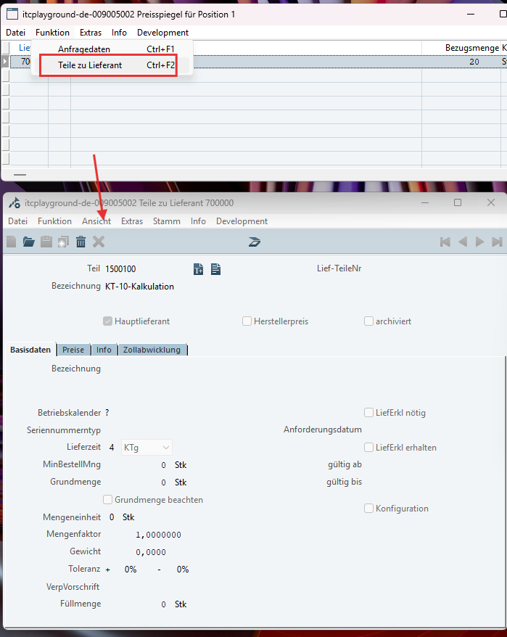
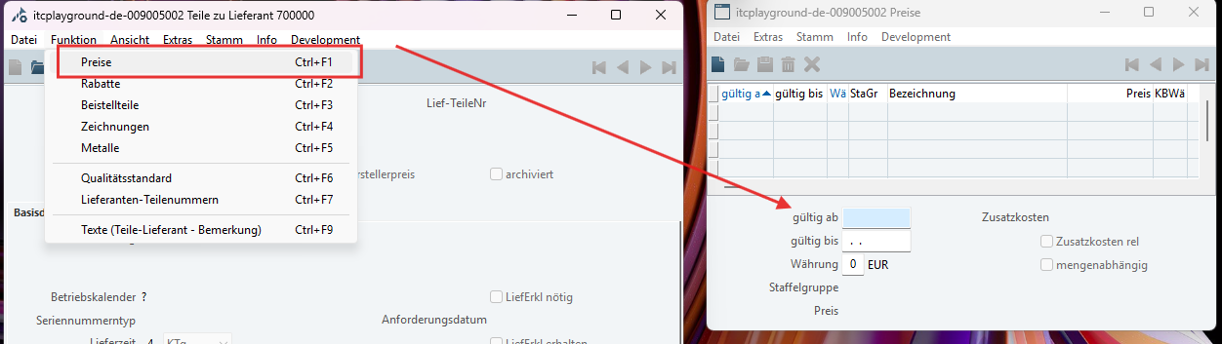
Gultig ab: From date
Gultig bis: To date (Optional)
Wahrung: Currency
Staffelgruppe: Price group such as 1,100,1000 the range of goods willn’t the same. (Optional)
Preise: Price
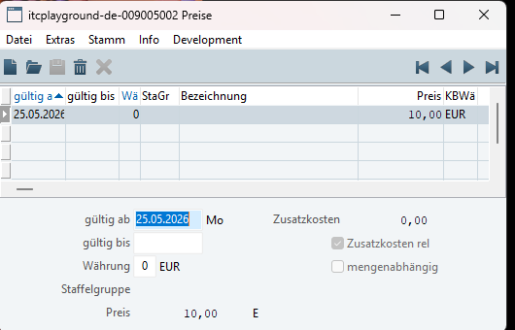
- After create at all, check the correct the goods has been create to buy? The column should be green like image.
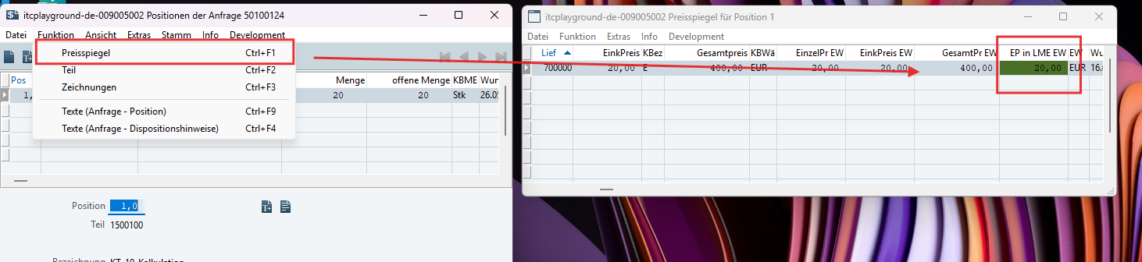
- After that we will generate to EB
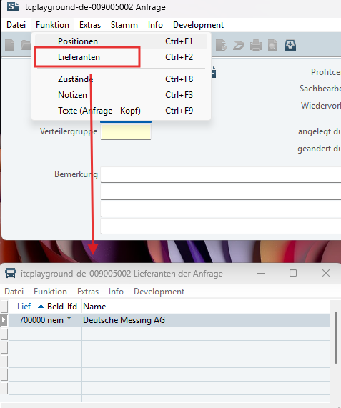
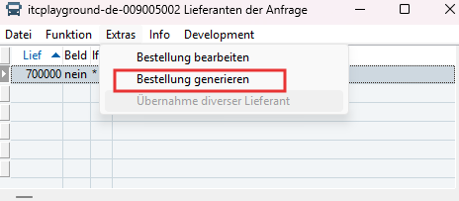
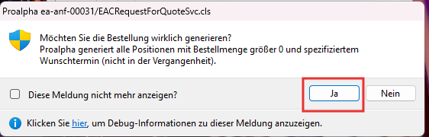
- Check the EAA has beed adopted to EB in
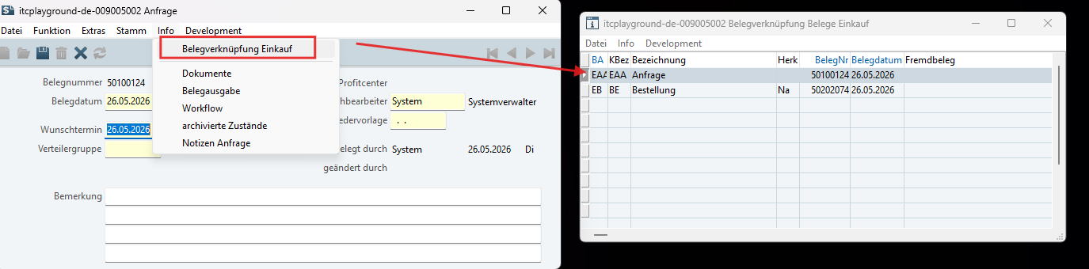
- Bestellung (EB) --> Wareneneingang (EWE)
- Open Wareneneingang and click new.
- Copy the number of Bestellung as you want and fill it.
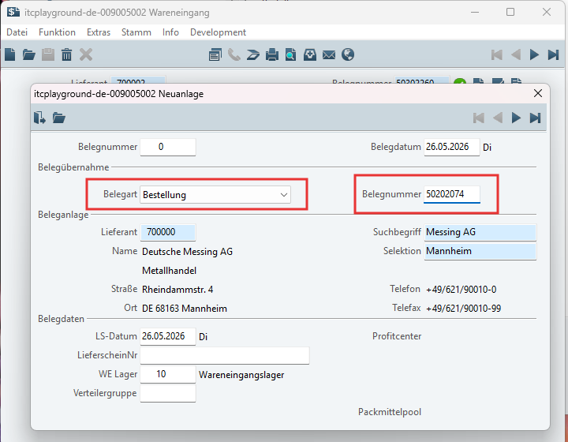
- If you are create and the dialog adoption not show you should run posting periods.
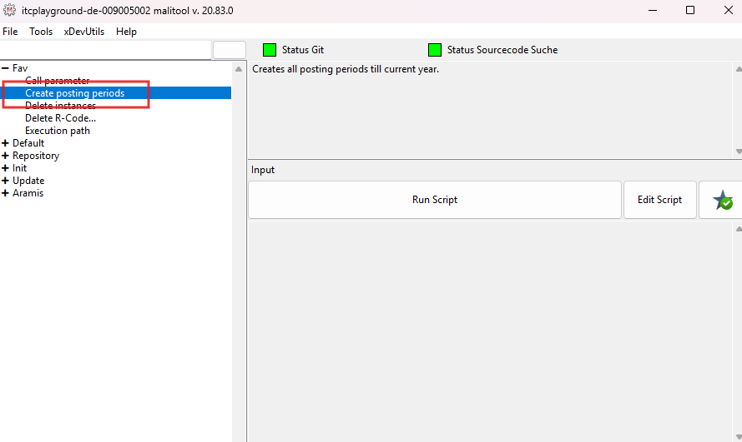
- After you create EWE you should got the dialog to adoption position like this:
- You can click komplettubernahme and click ok
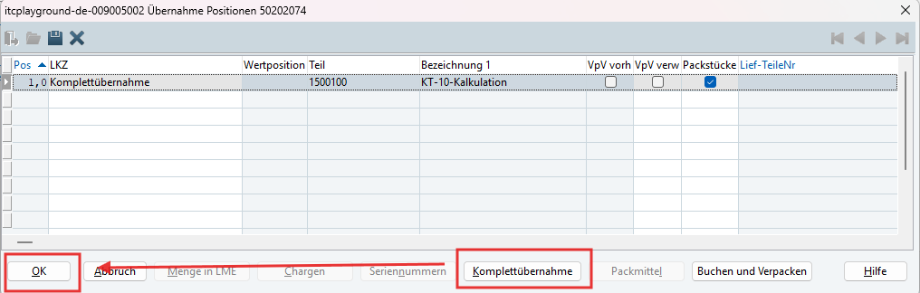
- Complete adoption
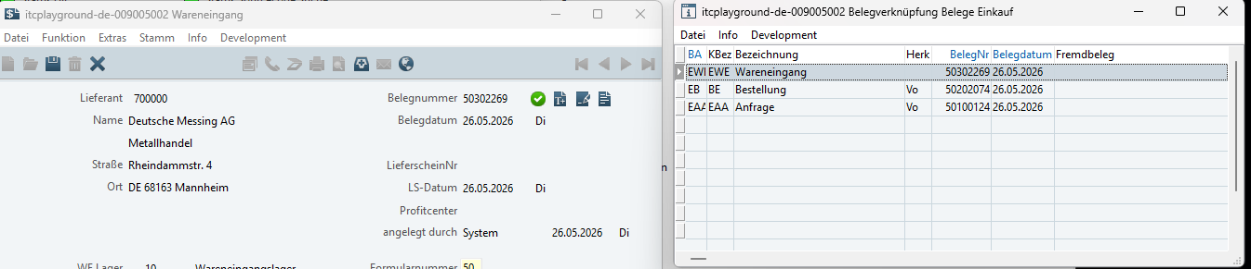

- Wareneneingang (EWE) --> Rechnungkontroll (ERR)
- Open new Rechnungkontroll (ERR) and click create.
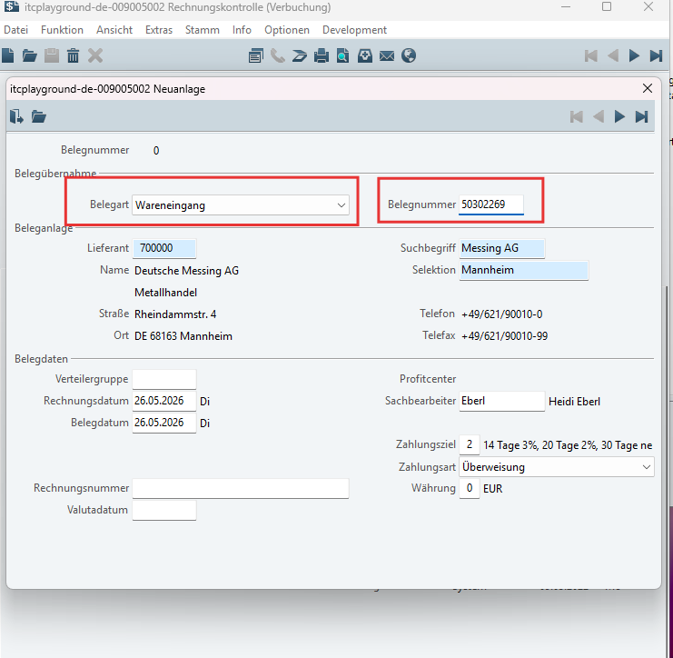
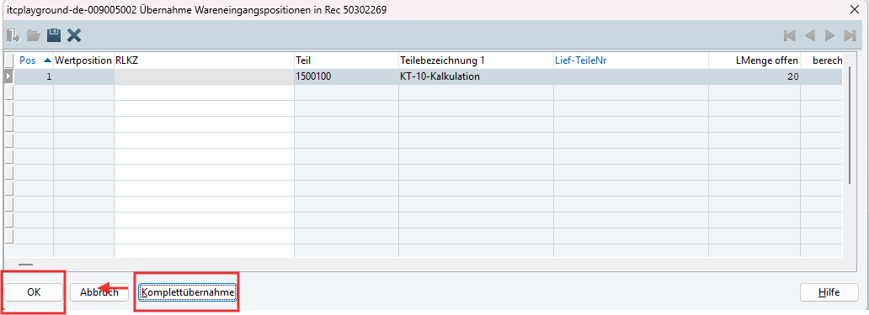
- Done
